**User Manuals for COMP3053CheckerTest**

First, user can setup the email and password need to check in setup() method.

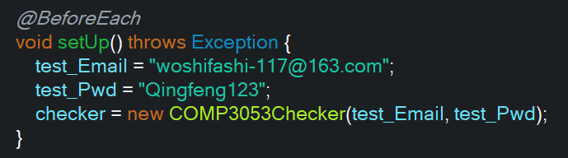

Second, run the test program, user will see the result of tests.

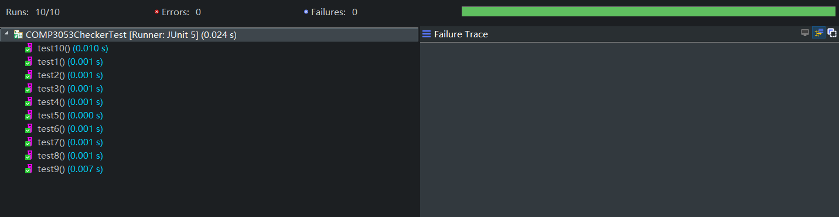

Third, if there are any failures, the right window will show them, user can change email or password in setup() method.